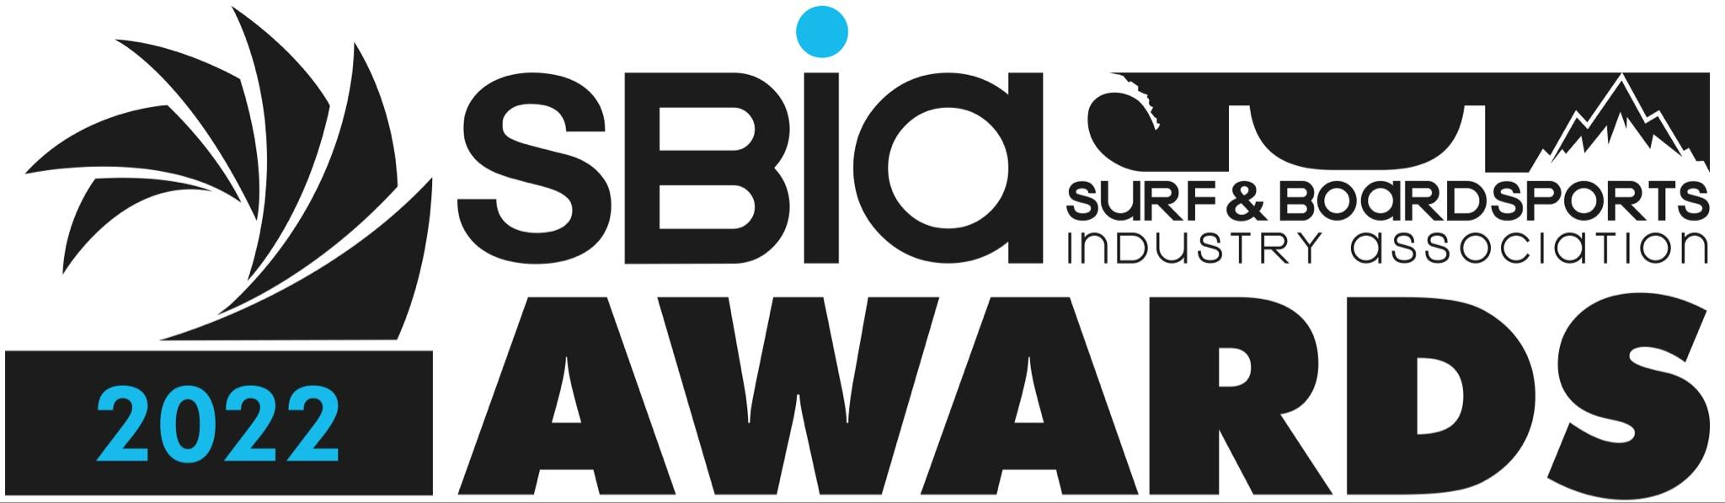

2022 Finalists of Voted Categories listed below in alphabetical order:
SALES AND CUSTOMER SERVICE OFFICE OF THE YEAR:

Boardriders Customer Service Team
Dragon Alliance
National Rip Curl Customer Service Office
Surf Hardware International Customer Service Team
The Leisure Collective (Creatures, Sex Wax, OTIS & sito)

ACCOUNT MANAGERS OF THE YEAR:

Andrew Forrest - Luxottica
Daniel Jenkin - Rip Curl
Josh Grimshaw - Quiksilver
Kerry Whitford - Rip Curl
Marty Farrow - Quiksilver
Terri Lea - Quiksilver

SALES AGENCY OF THE YEAR:

Bay Store
Carv N Co
Easey St
Reid Young Agencies
True East

WETSUIT OF THE YEAR:

Billabong - Furnace Comp
Quiksilver - Marathon Sessions
Rip Curl - Flashbomb Heatseeker
Vissla - Seven Seas
Volcom - Modulator Wetsuit

SURFBOARD OF THE YEAR:

Firewire - Mashup
JS Industries - “Schooner” model by Mikey Wright
Lost Surfboards by Mayhem - Rad Ripper
Ocean and Earth - The Ezi-Rider
Pyzel - The Ghost

SURFING ACCESSORY OF THE YEAR:

Creatures of Leisure - Italo Ferreira Signature Traction
Dakine - Jack Robinson Signature Traction
FCS Freedom Helix Leash
Ocean & Earth - Slimline
Rip Curl - Anti-Series Poncho

BOARDSHORT BRAND OF THE YEAR:

Billabong
Hurley
Patagonia
Quiksilver
Rip Curl

SUNGLASS BRAND OF THE YEAR:

Dragon Alliance
EPØKHE
Oakley
OTIS
Ray-Ban
FOOTWEAR BRAND OF THE YEAR:

Converse
Globe
Havaianas
Kustom
Reef

SWIMWEAR BRAND OF THE YEAR:

Billabong
Rip Curl
ROXY
Rusty
Salt Gypsy

SMALL TO MEDIUM BRAND OF THE YEAR:

Creatures of Leisure
Ocean and Earth
OTIS
Reef
RVCA

LARGE BRAND OF THE YEAR:

Billabong
Patagonia
Quiksilver
Rip Curl
Volcom

Finalists of Judged Categories listed below in alphabetical order:
Ladies Marketing Campaign of the Year

Billabong
Rip Curl - Summer Looks Good on You
ROXY

Men’s Marketing Campaign of the Year

Billabong
Dragon Alliance
Quiksilver
The Critical Slide Society
Volcom

Product Innovation

FCS
Rip Curl
Slater Designs
Spooked Kooks
Volcom

Environment Award

Global Surf Industries
Patagonia
Quiksilver
Rip Curl
Varuna Surf

Shop Fit Out Of the Year

Passport Surf
Rip Curl
Surfboard Empire

Australian Retailer of the Year – Single Store

Corner Surf Shop
Melbourne Snowboard Centre
Passport Surf
Star Surf + Skate

Australian Retailer of the Year – Multi Store
Hillzeez
Strapper Surf
Surfboard Empire

Australian Retailer of the Year – Core Board Store
Aloha Surf Manly
Strapper Surf
Surfboard Empire
Wicks Surf

